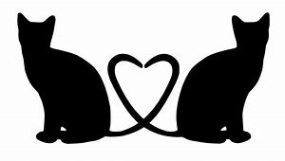
The Miaow Motel, Irchester
35 Gipsy Lane, Irchester, Northants NN29 7DJ
Tel: 01933 355370/0771 4181673/0781 5050364
Medication Consent Form
Please note that all information requested is a statutory requirement [CIEH Model Licence Requirements, 2013] and necessary to ensure the good health and protection of all our guests.
Cat’s name |  | Gender | Male/Female
Date of arrival |  | Date of departure
Medication Required [What is the medication for?]
Dosage |  | How many times a day?
When should medication be administered?
How should medication be stored? |  | Anything we should be aware of?

Double Check: Have you provided us with enough medication for the duration of your cat’s stay? If your flight/train is delayed will we have enough medication to cover a short delay?

I hereby consent to all suitably trained members of staff at the Miaow Motel administering the medication listed above to my cat for the duration of their stay.

Name Signed

Date

Many thanks from all at the Miaow Motel 

